1 Unmanagd memory

A . Total used 81.6 MB

B . Unmanagd memory 51.3 MB

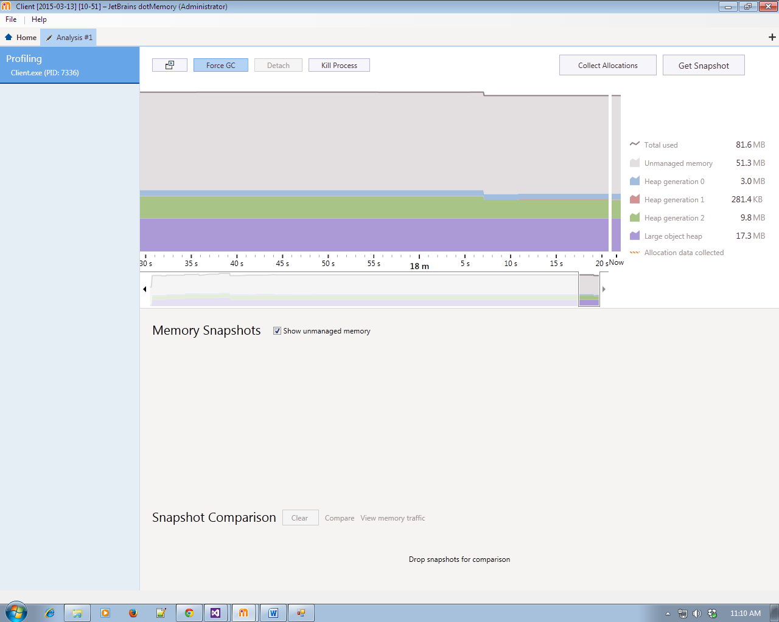

2 . Memory SnapShots

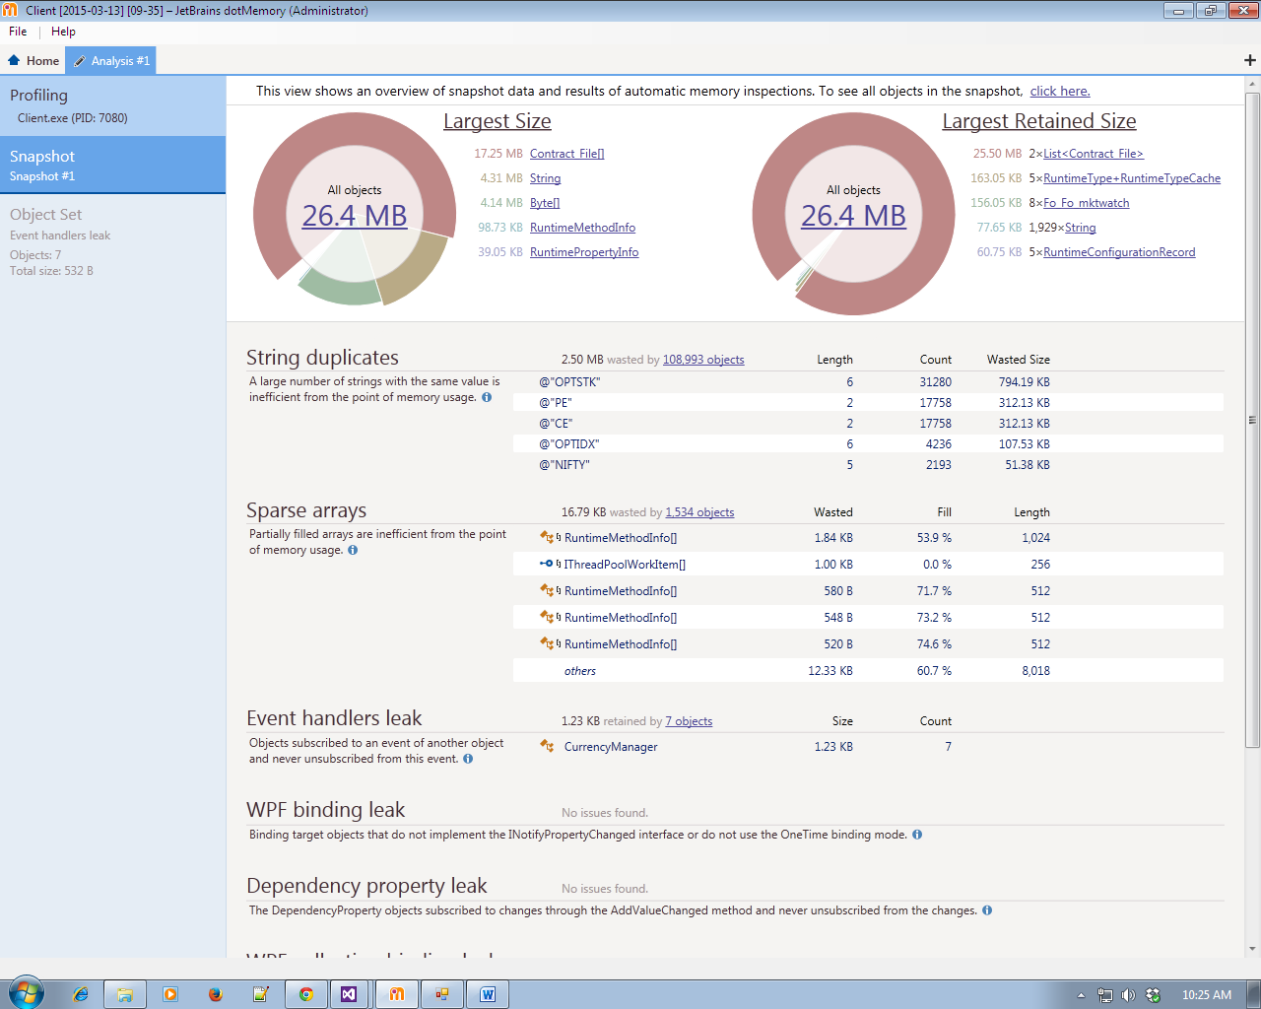

3 . Event Leak

A .Group By Shortest Path

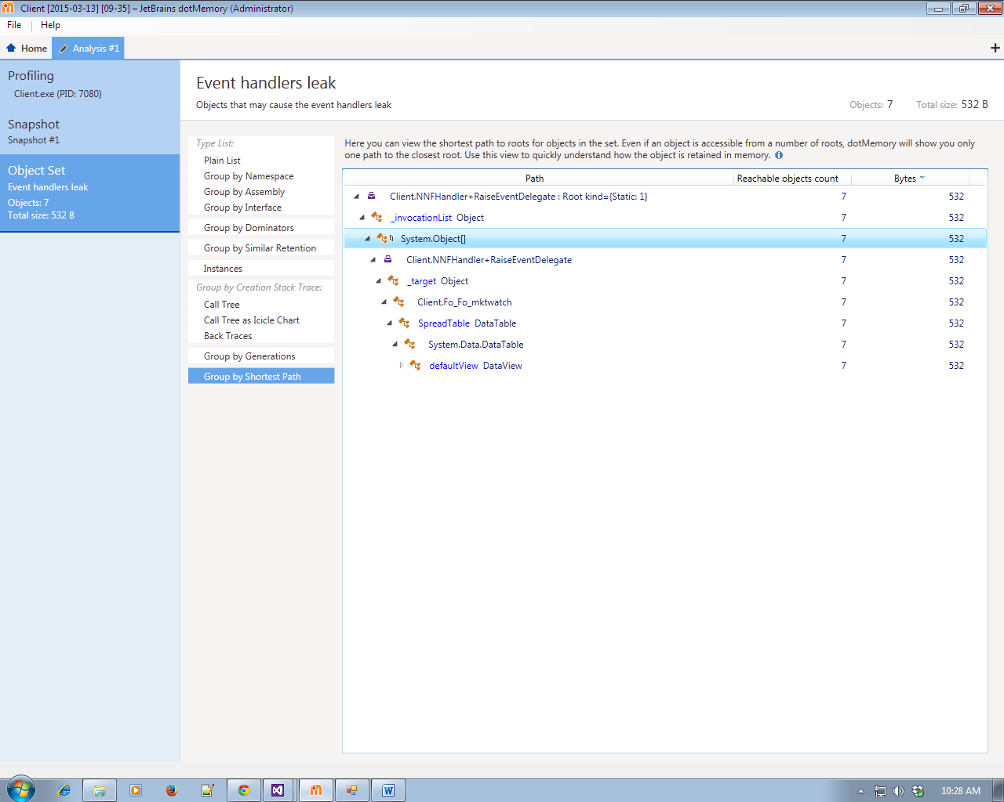

b. Here can view how domination the object set. The A is a dominator of B if it exclusively retains the latter in memory. If A is garbage collected B is also garbage collection.

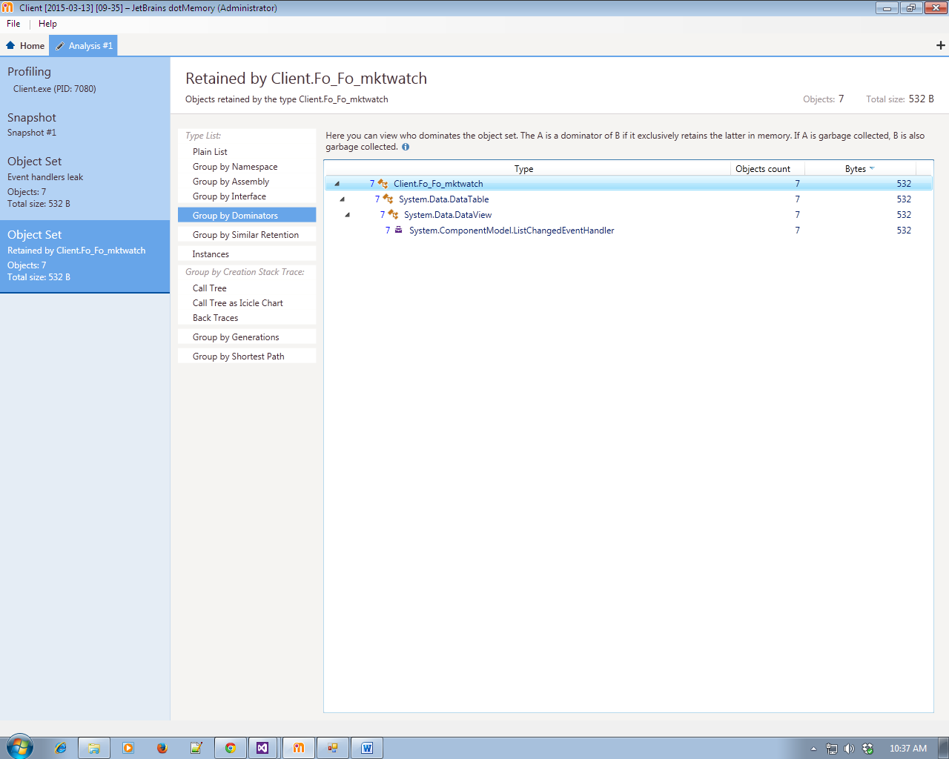

C . This view group object by similarity of their paths . The graph on the right show two key path to roots that’s are most different from each other.

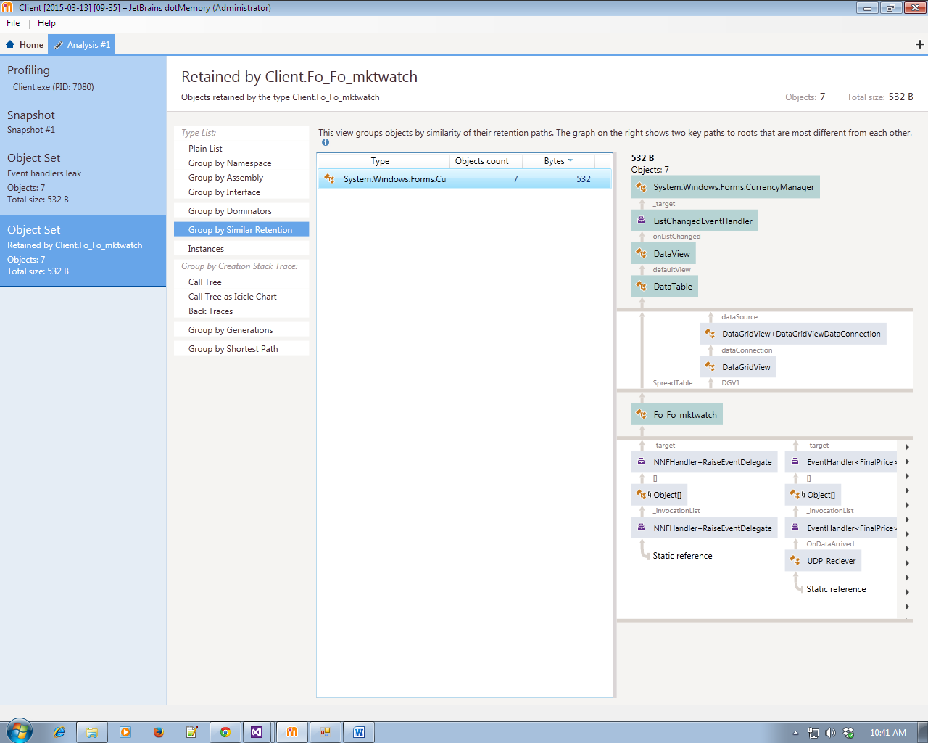

4 . Group by Assemebly

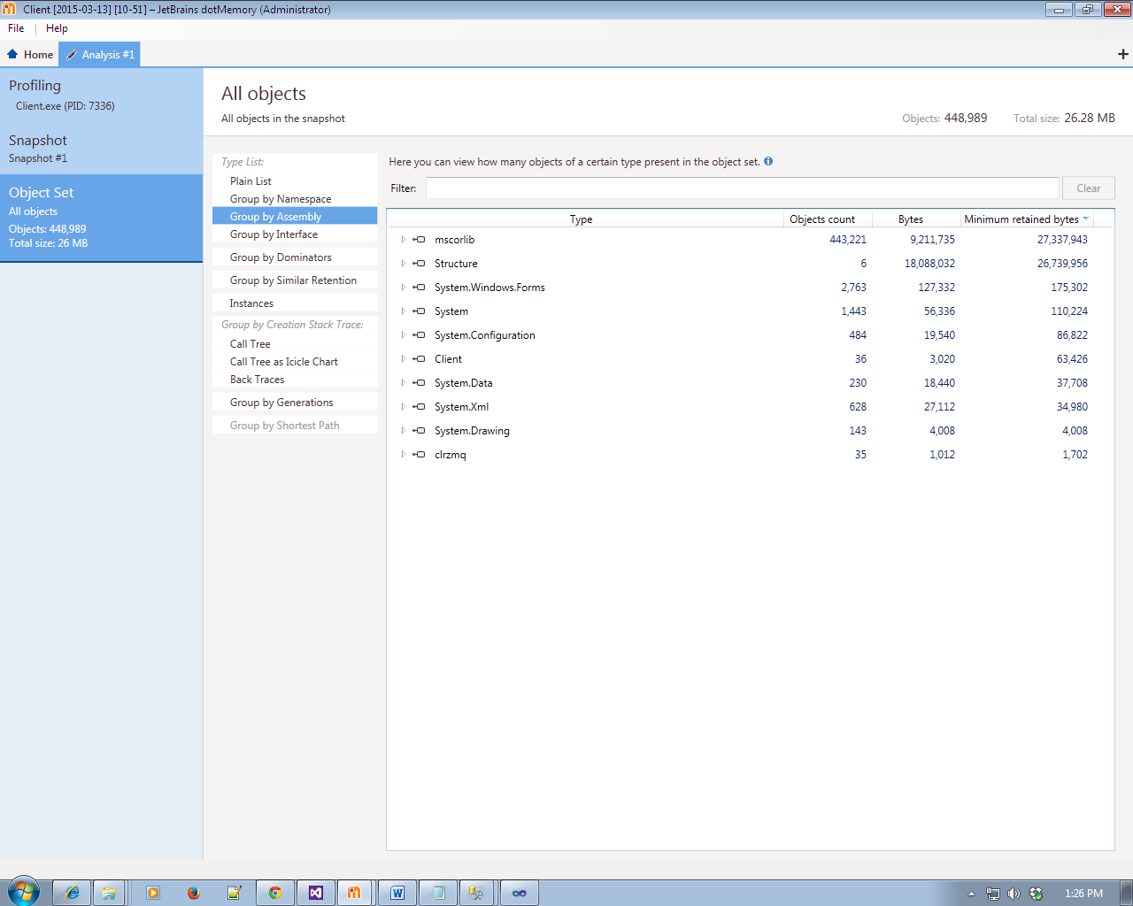

5 Group By Namespace

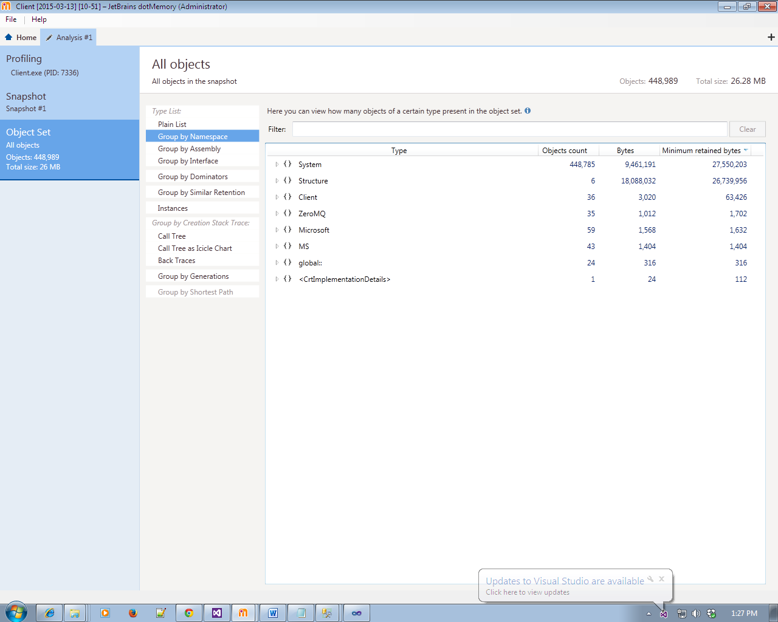

6 Group by Generation

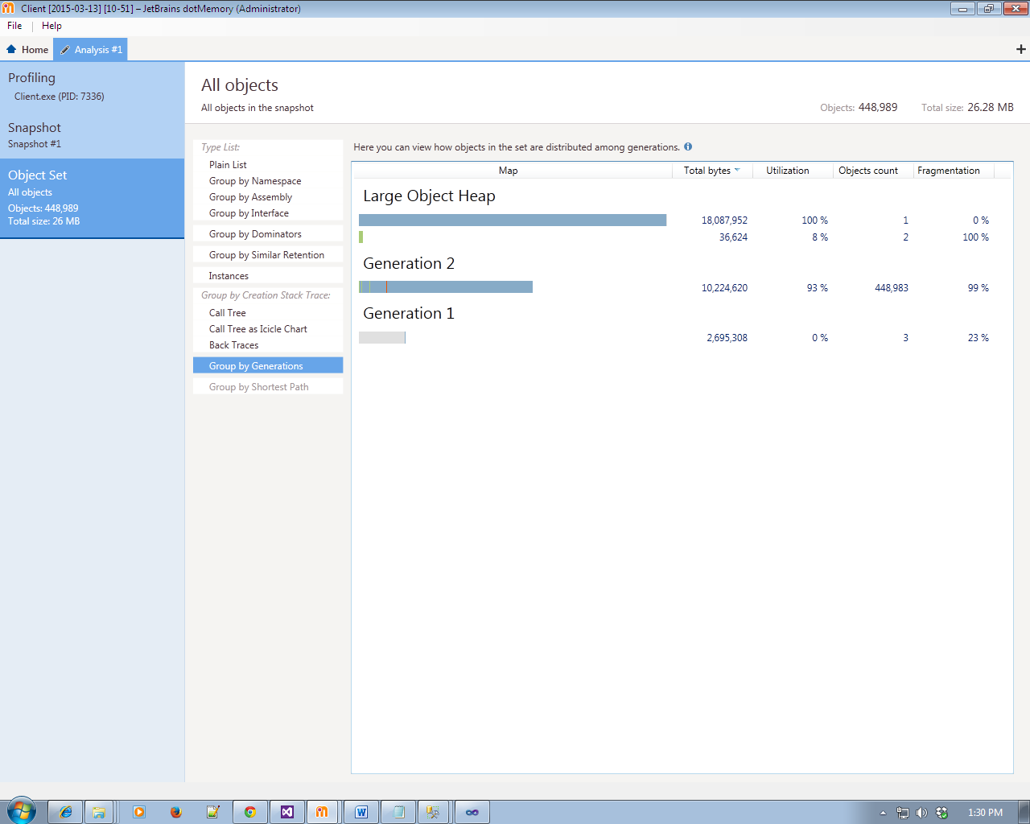

PROFILE STARTUP PROJECT

1 .Taking Class Time

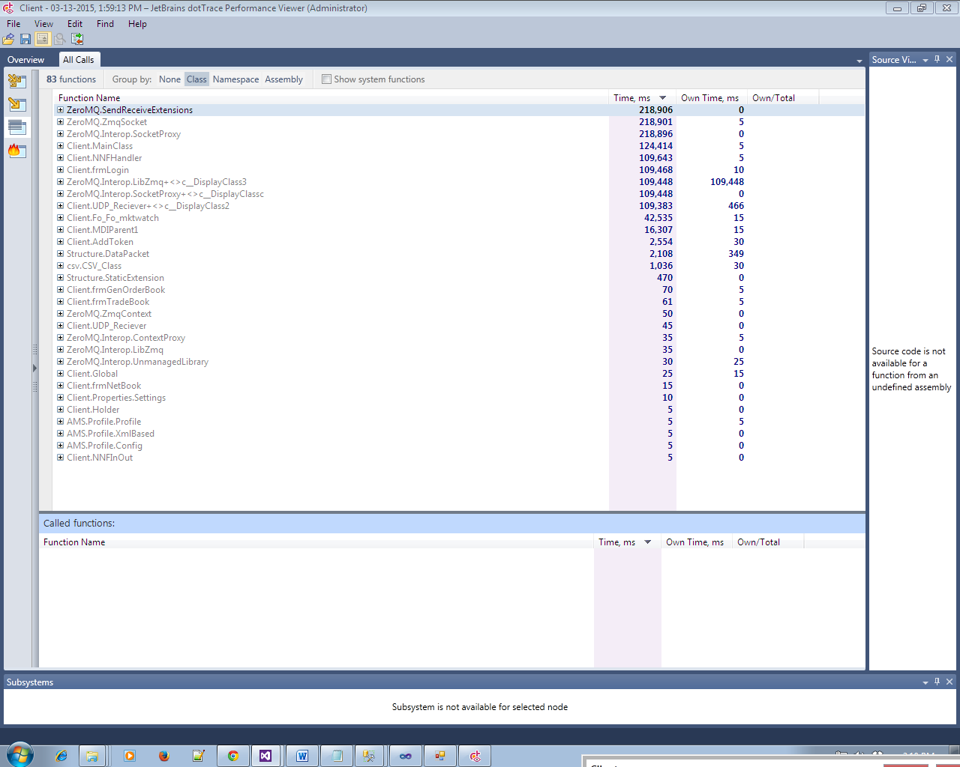

2 .Taking Namespace Time

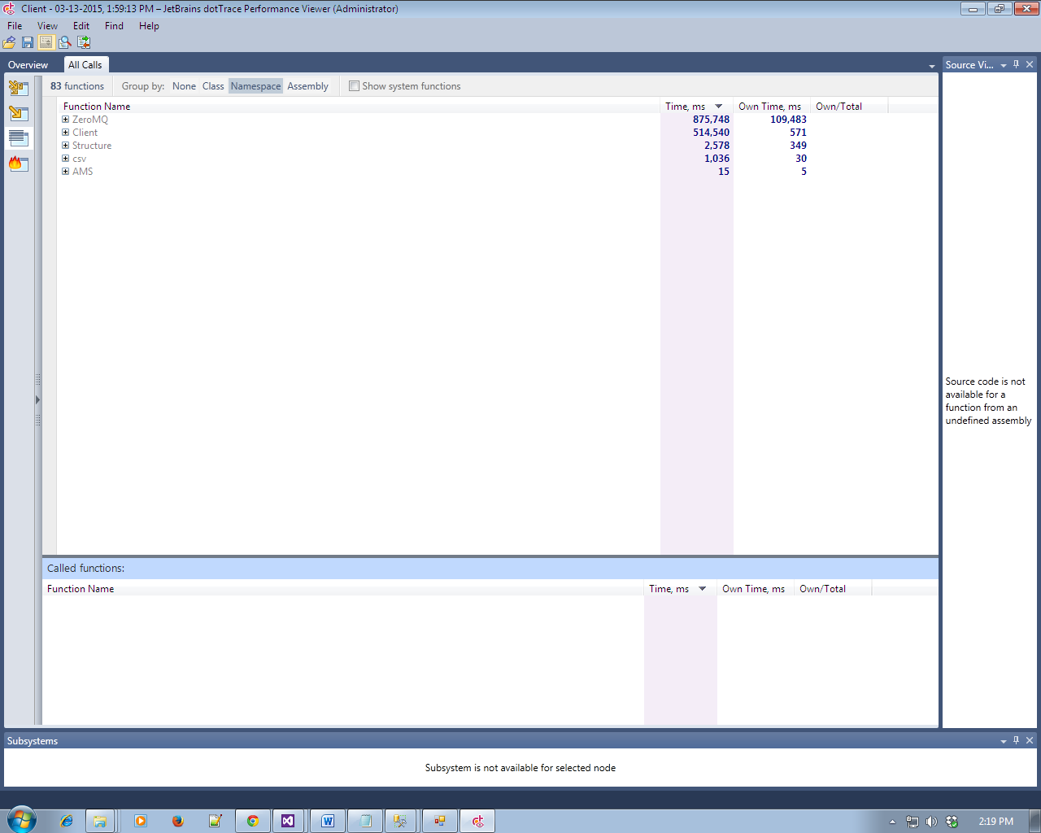

3.Taking Assembly Time

